**📘 DFD – Level 0 (Context Diagram)**

**Entities:**

* **User (Woman in danger)**
* **Police Department**
* **Hospital / Safe Shelter**
* **Firebase (Backend)**

**Process:**

* **Women Safety App System**

**Data Flows:**

* User → App: Input (location, emergency alert, audio/video)
* App → Police: Alert + Location + User Info
* App → Hospital: Request for help/shelter
* App ↔ Firebase: Store/Fetch Data (location, recording, logs)

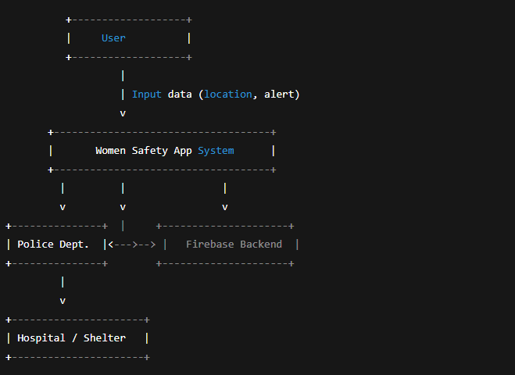

## 📘 ****DFD – Level 1 (Detailed)****

### ****Processes:****

1. **1.0 User Input Handling**
2. **2.0 Emergency Alert System**
3. **3.0 Location & Recording Management**
4. **4.0 Data Sync with Firebase**
5. **5.0 Send Alerts to Contacts / Police**

### ****Data Stores:****

* **D1: User Profile**
* **D2: Location Logs**
* **D3: Media Recordings**
* **D4: Emergency Contacts**

### ****Data Flows:****

* User → 1.0 → GUI Inputs
* 1.0 → 2.0 → Triggers SOS
* 2.0 → 5.0 → Sends alerts to police/hospital
* 3.0 ↔ Firebase
* 3.0 → D2/D3
* 4.0 → Firebase Sync

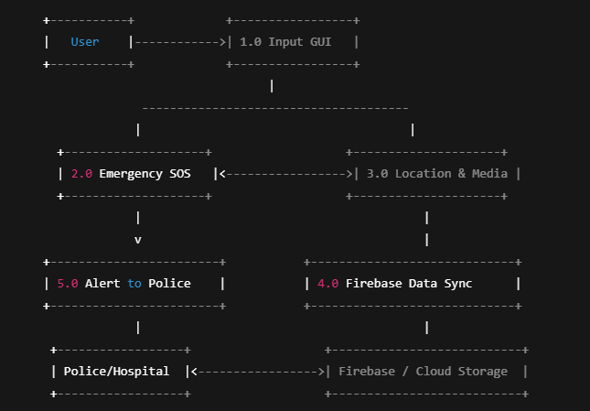

## 📦 ****Data Stores (D1–D4)****

* **D1:** Stores user profile and settings.
* **D2:** Location logs and shared coordinates.
* **D3:** Audio/video recordings during incidents.
* **D4:** List of emergency contacts, hospital numbers, police station numbers.

